NIT6004
Neural Network and Deep Learning
Project 1

TITLE:
DEVELOP AN IMAGE CLASSIFIER USING BASIC NEURAL NETWROKS WITH FEW DIFFERENT OPTIMIZERS

By
PRAVEEN GIDDI
S8162510

LECTURER
Dr. DULIP HERATH

Table of Contents
Introduction 3
Literature Review 3
The methods applied for solving each task and reason for choosing 5
Results 6
Challenges and problem during project 13
Conclusion 16
References 17
Data Privacy 18
Professional Ethics 18

Introduction
Image classification is among the most extensively utilized techniques in the field of machine learning, serving as the foundation for technologies that range from postal code identification to self-driving vehicles. At its essence, image classification entails training a model to accurately assign a label to a given image, a task for which neural networks are particularly adept due to their capacity to learn hierarchical representations directly from raw pixel data.

This project focuses on developing a digit classifier utilizing the MNIST dataset, which comprises 70,000 images of handwritten digits (with a division of 60,000 for training and 10,000 for testing) compiled by Yann LeCun. Each image is represented in a 28x28 grayscale pixel format depicting digits from 0 to 9. While this dataset may appear simplistic compared to contemporary datasets, MNIST continues to serve as a standard benchmark for assessing neural network architectures due to its manageable size and accurate labeling.

The primary aim of this project is to design, train, and evaluate a Multi-Layer Perceptron (MLP) classifier for recognizing MNIST digits, as well as to test various optimizers to compare their impact on model performance. This report details the methodology employed at each stage, assesses the results obtained, and discusses the broader ethical considerations pertinent to the deployment of such classification systems.

Literature Review
The MNIST dataset was first presented by LeCun, Bottou, Bengio, and Haffner in 1998 (Lecun, Y., Bottou, L., Bengio, Y., & Haffner, P, 1998) as part of their research on gradient-based learning techniques for document recognition. They illustrated that convolutional neural networks could deliver impressive results in recognizing handwritten digits. Since its introduction, MNIST has established itself as a fundamental benchmark for assessing new neural network architectures and training methodologies, primarily due to its straightforward nature and meticulously curated labels.

Initial methods for classifying MNIST utilized simpler algorithms such as k-nearest neighbors and support vector machines, which achieved commendable yet limited accuracy. The advent of Multi-Layer Perceptron (MLP) marked an advancement by enabling the network to learn non-linear feature representations through hidden layers. However, MLPs compromise spatial structure by transforming the image into a single vector, in contrast to Convolutional Neural Networks (CNNs), which subsequently emerged as the prevailing architecture for image-related tasks. The selection of an optimizer has also been demonstrated to significantly influence training dynamics and convergence rates. Utilizing an appropriate optimizer can minimize prediction errors. Stochastic Gradient Descent (SGD) was the initial standard optimizer, but adaptive techniques such as RMSprop and Adam were later introduced to dynamically adjust learning rates for each parameter, typically resulting in quicker convergence and enhanced stability on datasets like MNIST. By employing an optimizer, (Science Insights Team. (2026) it determines the direction in which the networks should adjust for improved performance with each iteration.

This project builds upon the established body of research by implementing and comparing the MLP classifier with various types of optimizers on the MNIST dataset.

The methods applied for solving each task and reason for choosing

- While I’m solving the model accuracy, I’ve chosen three parameters like “Stochastic Gradient Descent”, “Root Mean Square Propagation”, “Adaptive Moment Estimation”.

- I tried creating a while loop with defined optimizers names because rather going with each, I’ve created a loop with listed optimizers
- 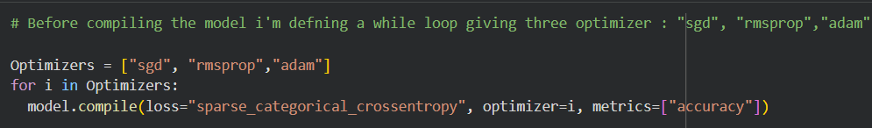

Results
- Successfully imported all the required libraries
- 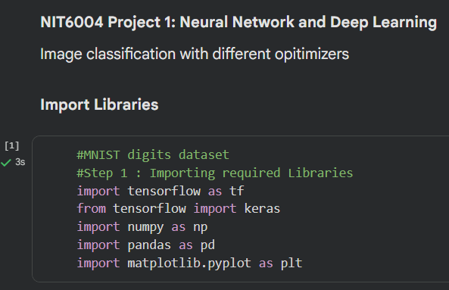

- Importing the Dataset and Splitting the dataset
- 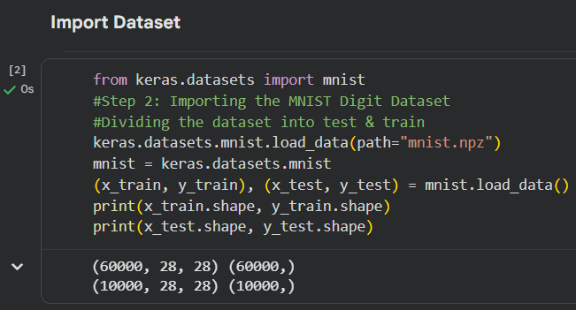

- Scaling the dataset
- 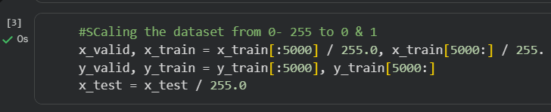

- Checking the plot
- 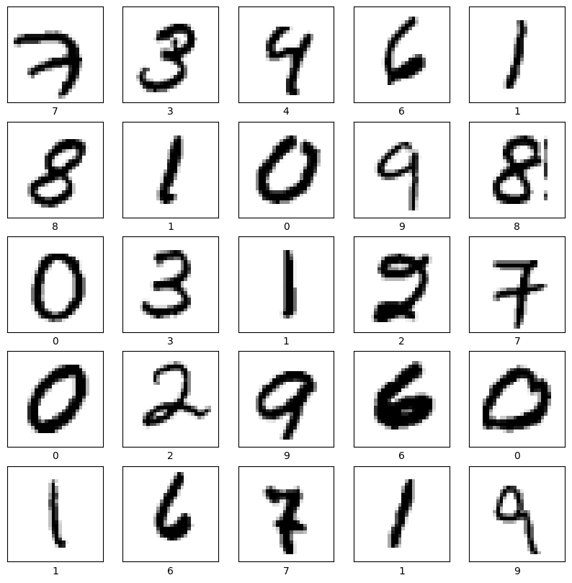
- 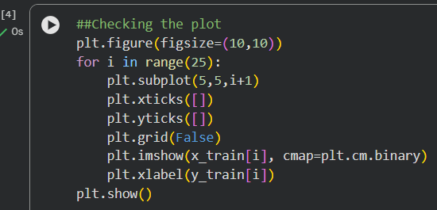

- Building the Classifier using MLP
- 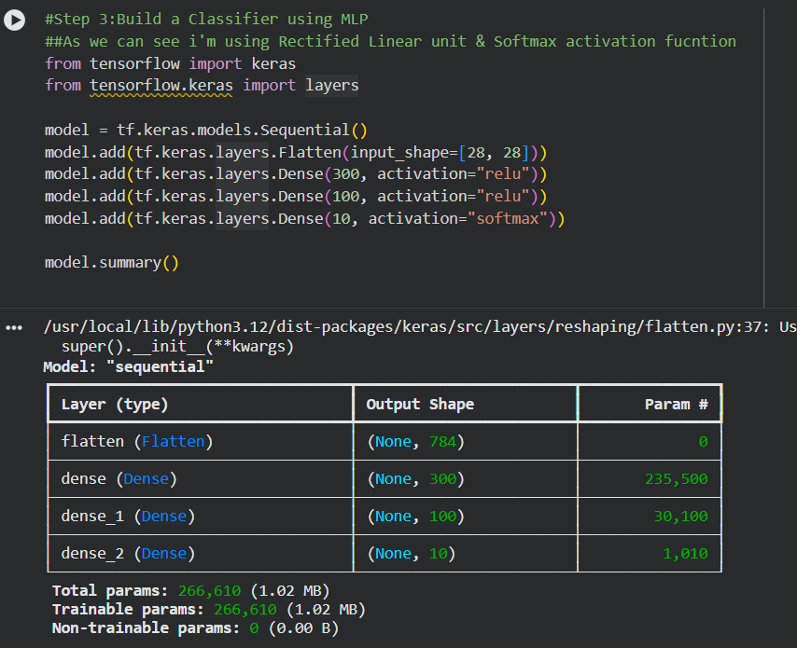

- Compiling the model with different parameters

- 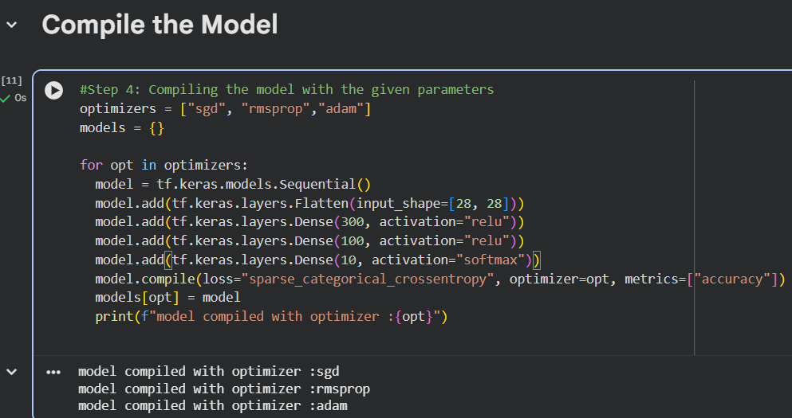

- Training and testing the model
- 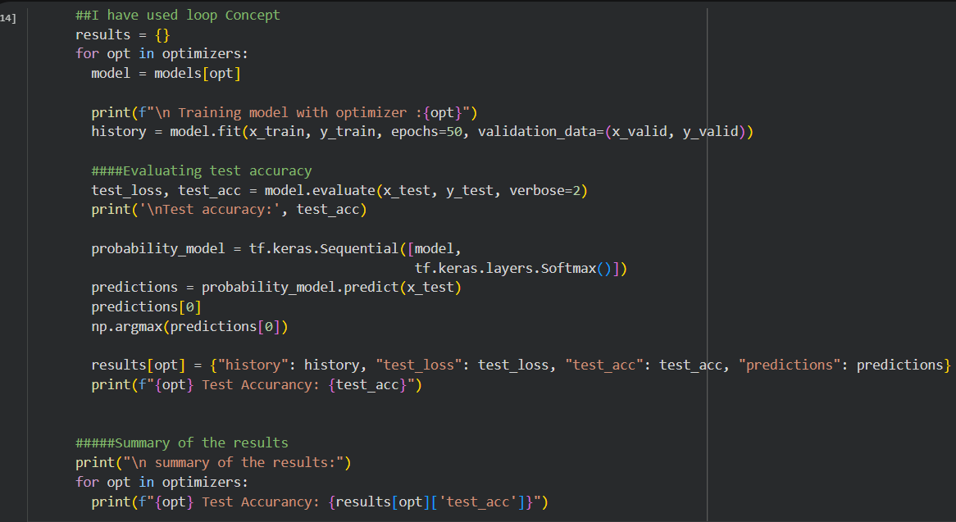

- Summary of Test

- 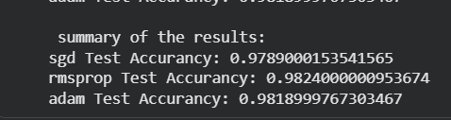

- Summary of Train

sgd

rmspropp

adam

- Plotting Accuracy and Loss Curve
- 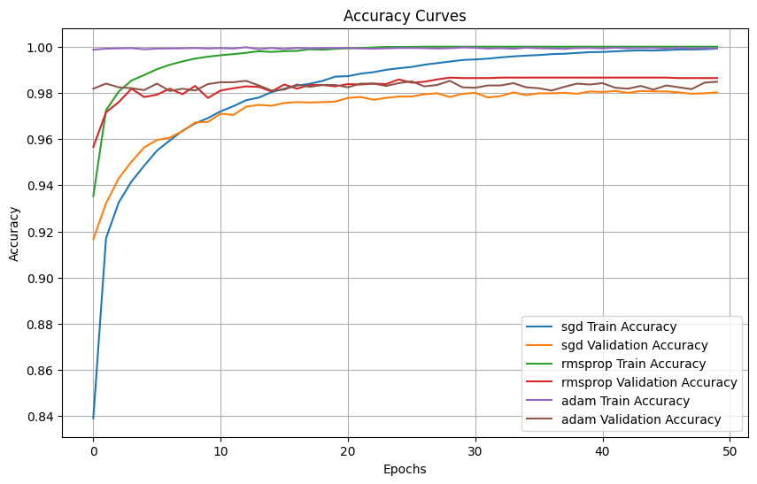

- 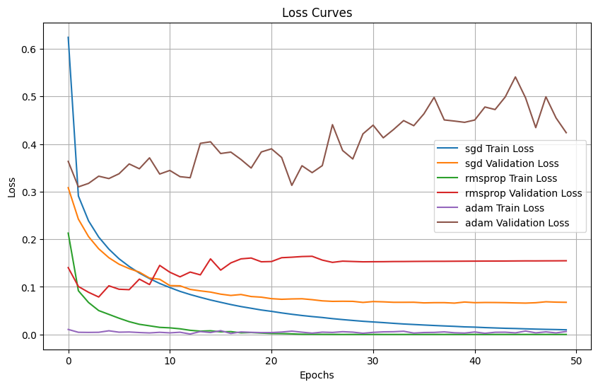
- SGD is observed to be the most stable and generalizable optimizer in this specific context, demonstrating reliable performance on both training and validation datasets with negligible overfitting.

- RMSprop exhibits indications of overfitting, as evidenced by the divergence of its validation loss from the training loss, albeit to a lesser extent than Adam.

- Adam displays the most pronounced signs of overfitting. Although it rapidly attains very low training loss and high training accuracy, its validation performance deteriorates swiftly, suggesting that it has excessively memorized the training data and encounters difficulties with novel examples.

Challenges and problem during project
- While I’m trying to building the Classifier MLP i had a question like why can’t I apply the different dense layers like 124, 64 rather going with the standard 300,100,10. I have chosen the standard dense layers 300,100,10.

- Had an issue with the Loop concept while trying to define the Optimizers. I got the error showing key argument. I’ve resolved it changing the name Optimizer with singular and lowercase “optimizers”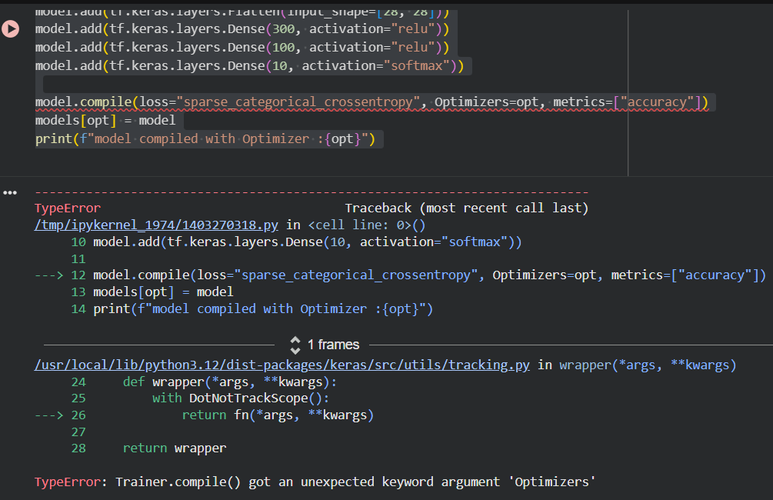

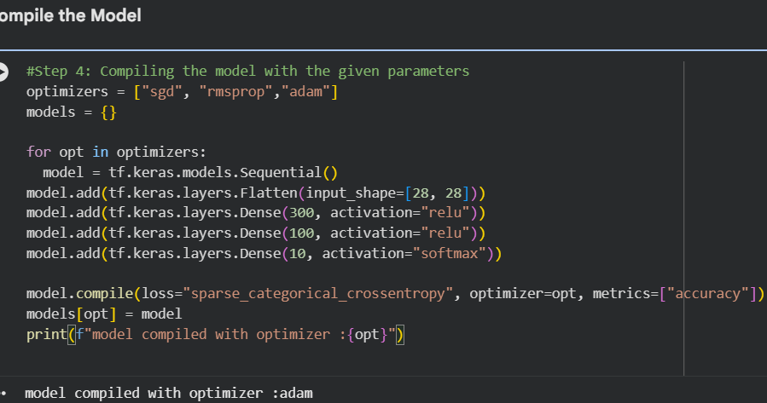

- I had issue with loop I’ve defined some content outside the loop instead inside the loop then instead of getting three optimizers Ive got only one optimizer “adam”
- 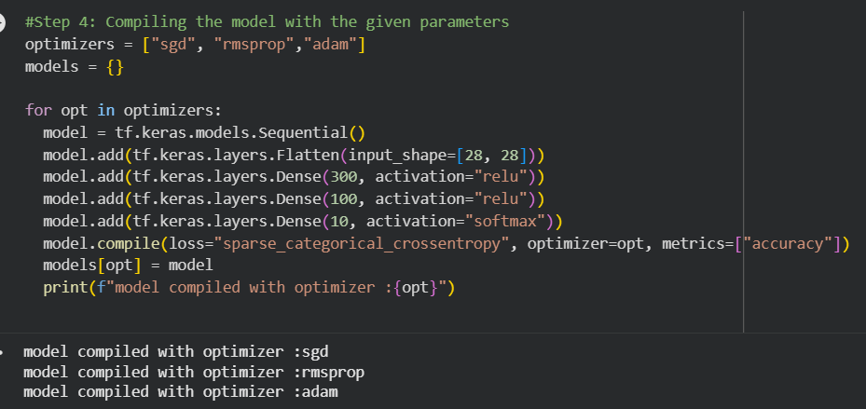
- I’ve segregated everything under one loop, then I got the result.

- 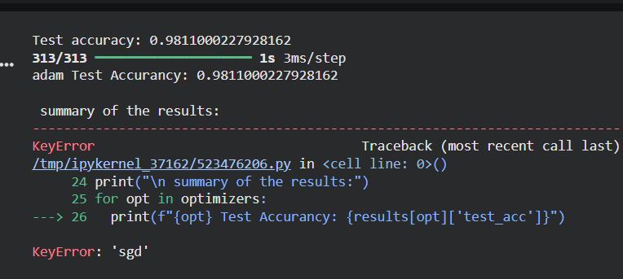

Conclusion
SGD is recognized as the most stable and generalizable optimizer within this particular context, showcasing consistent performance across both training and validation datasets with minimal overfitting. RMSprop shows signs of overfitting, as indicated by the divergence between its validation loss and training loss, though this occurs to a lesser degree compared to Adam. Adam exhibits the most significant indications of overfitting. While it quickly achieves very low training loss and high training accuracy, its validation performance declines rapidly, implying that it has overly memorized the training data and struggles with new examples.

References

- Science Insights Team. (2026, March 10). What is a neural network optimizer and how it works - ScienceInsights. ScienceInsights. https://scienceinsights.org/what-is-a-neural-network-optimizer-and-how-it-works/

- Lecun, Y., Bottou, L., Bengio, Y., & Haffner, P. (1998). Gradient-based learning applied to document recognition. Proceedings of the IEEE, 86(11), 2278–2324. https://doi.org/10.1109/5.726791

- Keras API reference — Datasets. (2026a, August). Keras. https://keras.io/api/datasets/

- Tf.keras.Sequential. (2026b, August). TensorFlow. https://www.tensorflow.org/api_docs/python/tf/keras/Sequential

- Chollet, F. (2021). Deep learning with python (2nd ed.). Manning Publications.

Data Privacy
The MNIST dataset poses minimal risk as it consists of anonymized images of digits devoid of any identifiable information. Nevertheless, certain methodologies could be relevant to sensitive personal data, including medical records or biometric images, which raises significant privacy issues. Two primary risks are evident:
Unauthorized collection of data without the individual's consent.
Insufficient safeguarding of stored images that may be linked back to personal information.
The suggested solution involves implementing data minimization techniques or de-identifying images prior to training, as well as securing explicit consent when handling personal data, in accordance with data protection regulations such as the Australian Privacy Principles.

Professional Ethics
The dataset utilized for this project represents a straightforward academic exercise within a university context. The technique employed, namely Supervised Image Classification, is directly relevant to real-world applications and thus necessitates ethical scrutiny, guided by a well-established framework of professional integrity.

The Australian Computer Society (ACS) Code of Professional Conduct offers a pertinent perspective, founded on essential values that include the primacy of public interest, enhancement of quality of life, honesty, competence, and ongoing professional development. Applying these values to the current scenario reveals several ethical concerns:

Bias & Fairness: While the MNIST Dataset is considered balanced and of good quality, real-world image classifiers are frequently trained on datasets that inadequately represent certain populations, resulting in biased predictions. According to the ACS principle prioritizing public interest, IT professionals are obligated to ensure that training data is both diverse and representative prior to deploying a model in a production environment, especially in sensitive areas such as identity verification.

Transparency & Accountability: Neural networks often operate as "black boxes," complicating the explanation of the rationale behind specific decisions. This situation contradicts the ACS principles of honesty, which mandate that professionals accurately convey the capabilities and limitations of systems to stakeholders. A suggested approach is to provide deployed models with comprehensive documentation detailing their accuracy, limitations, and use cases, while also incorporating human oversight for high-stakes decisions instead of relying solely on automation.

Competence & Misuse: Methods similar to those utilized in this project may be misused for activities such as surveillance or illicit identity tracking. It is the ethical duty of professionals, consistent with the ACS principle of enhancing quality of life, to consider the possible future applications of the technologies they create and to dismiss any evidently detrimental use cases.

